Name :- M.Ravi

Ph no :- 6302540471

Batch :- 119

E-mail :-ravimylarapu39@gmail.com

Assignment :- peering connection

Asssignment-1

1. First create a new vpc

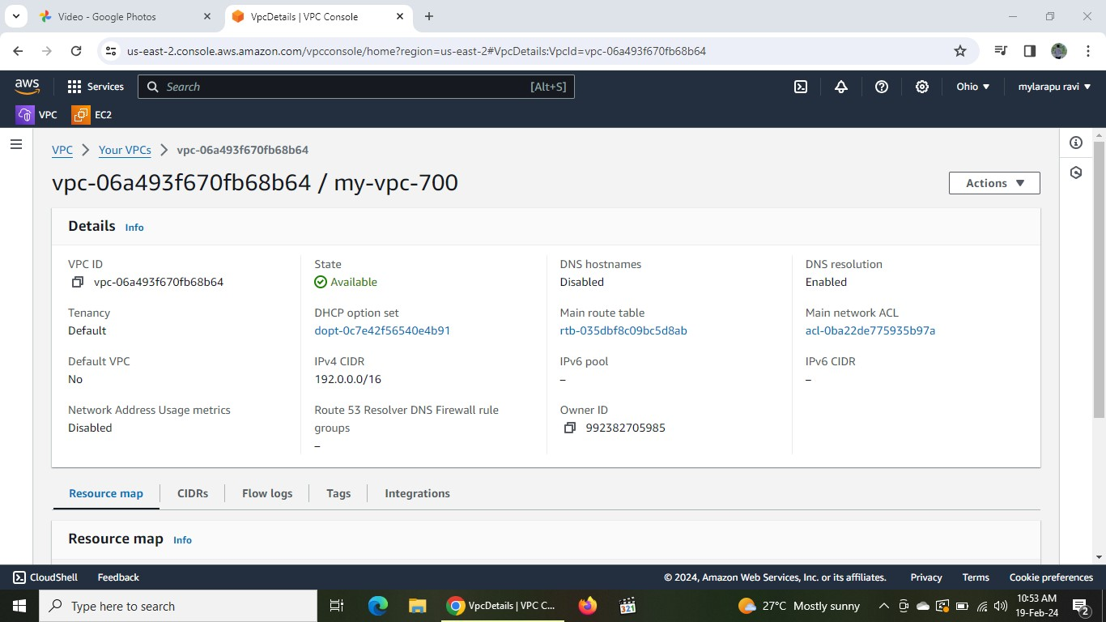

2.next create one subnet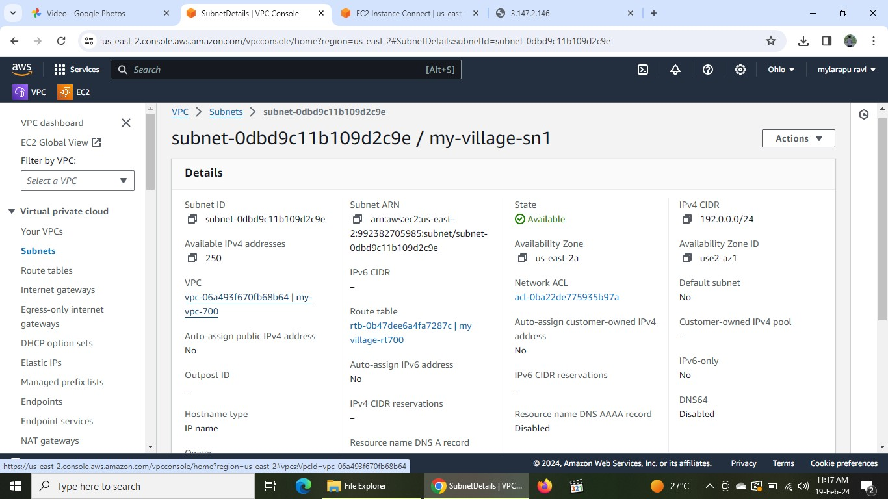

3.next create internet gateway and attached to the vpc

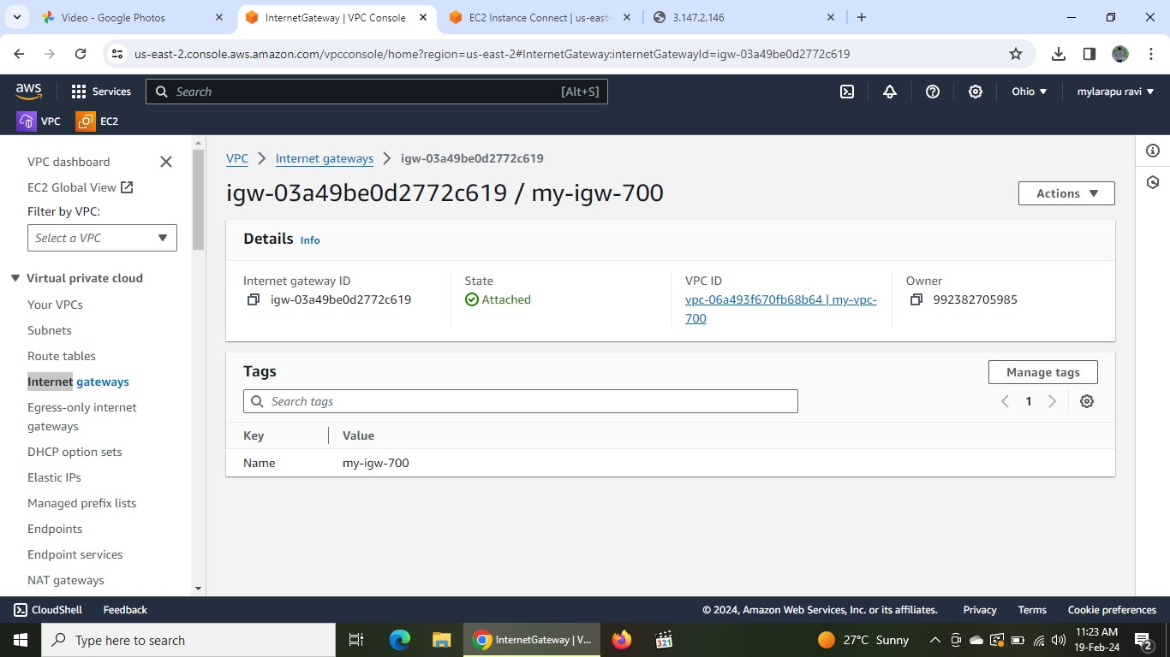

4.next create the route table go to the security edit routes connect to the internet gateway and also add subnet to the route table

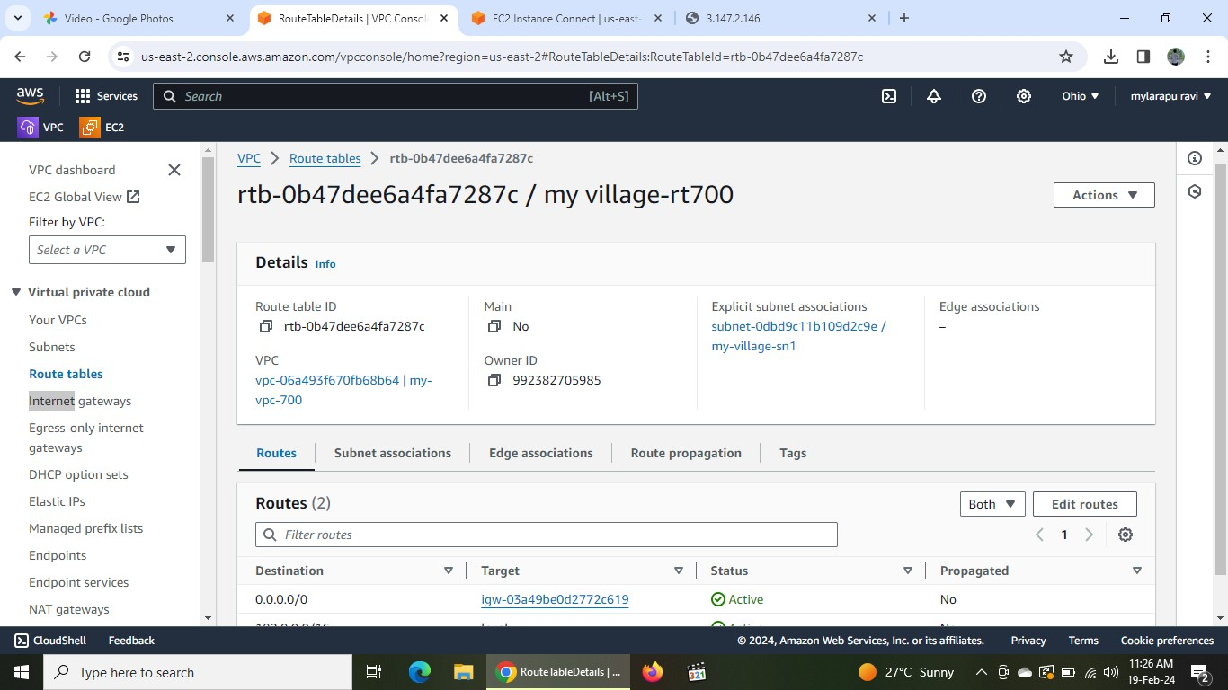

5.after connections are established in vpc

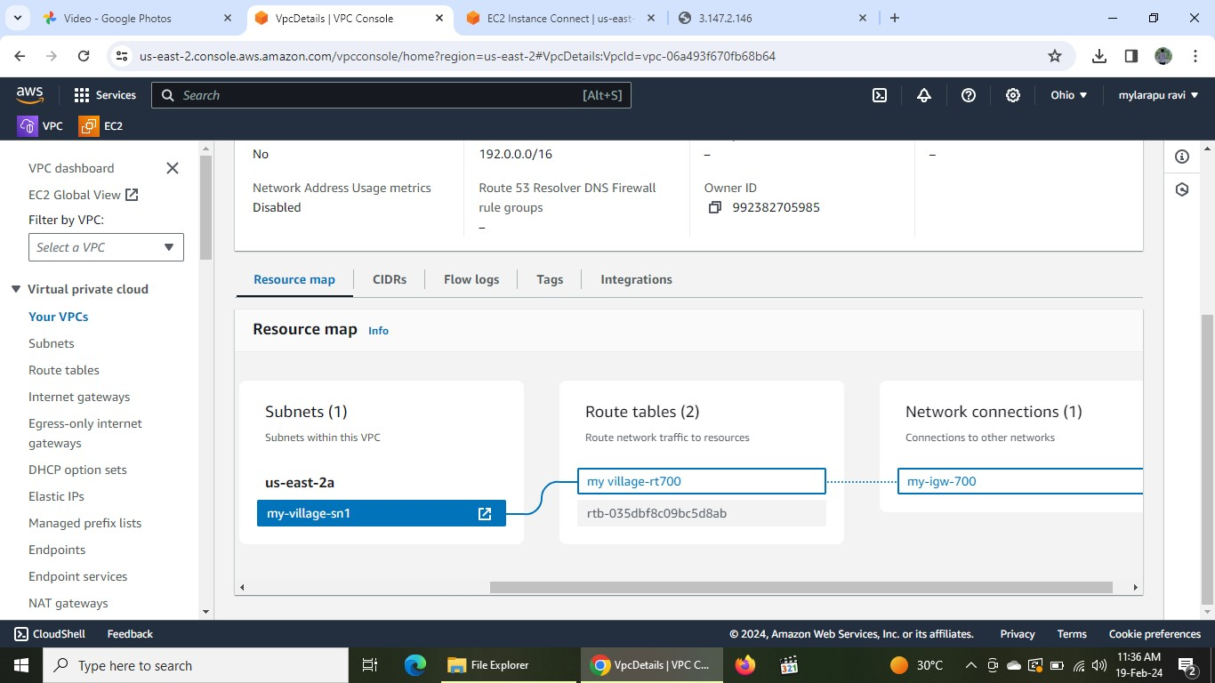

6.next go to the ec2 instance and launch instance go to the security settings select cidr range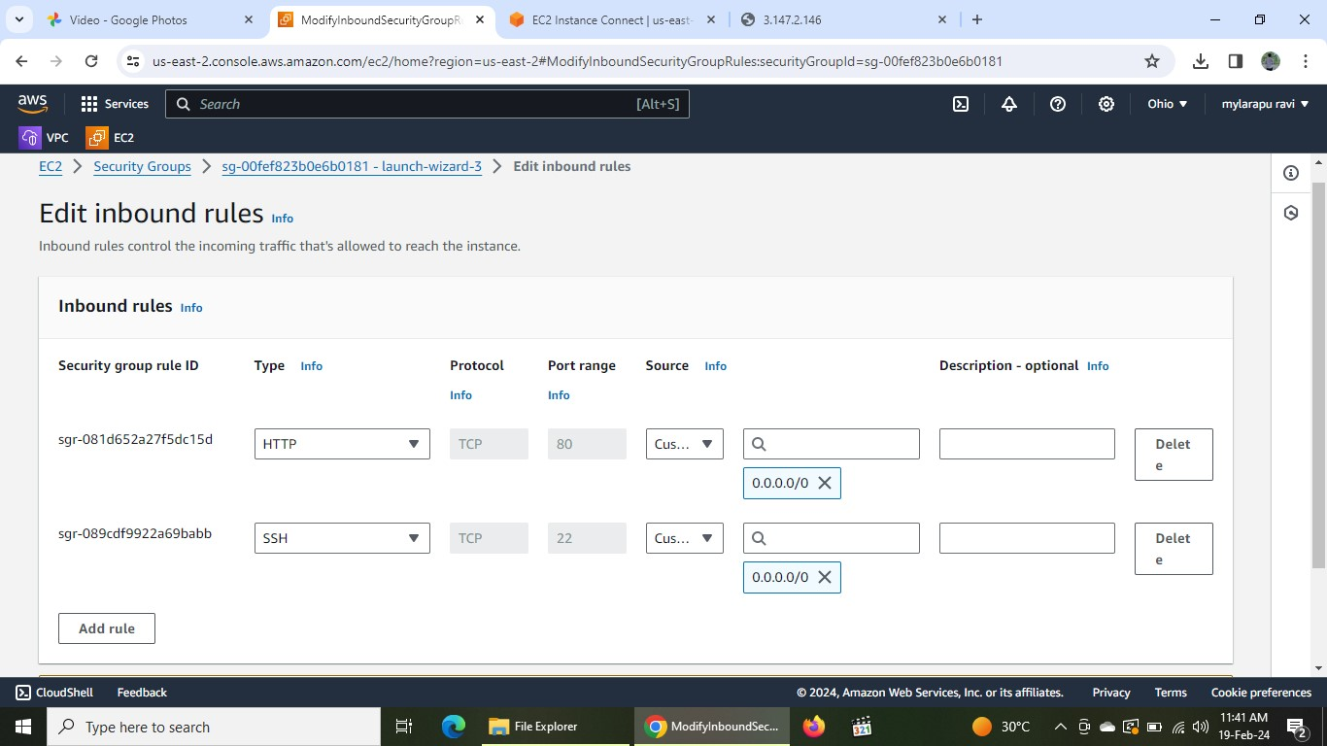

7.next install nginx

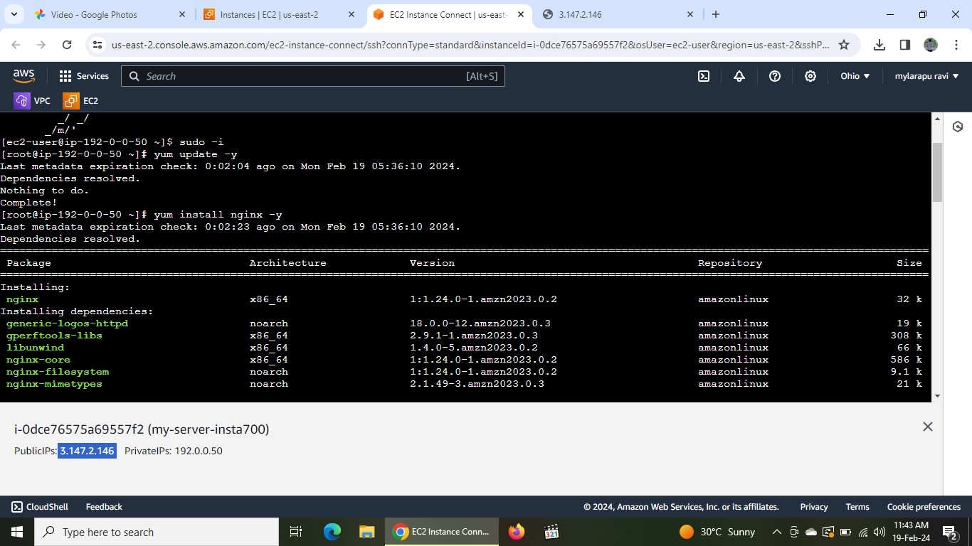

8.use vi command insert the data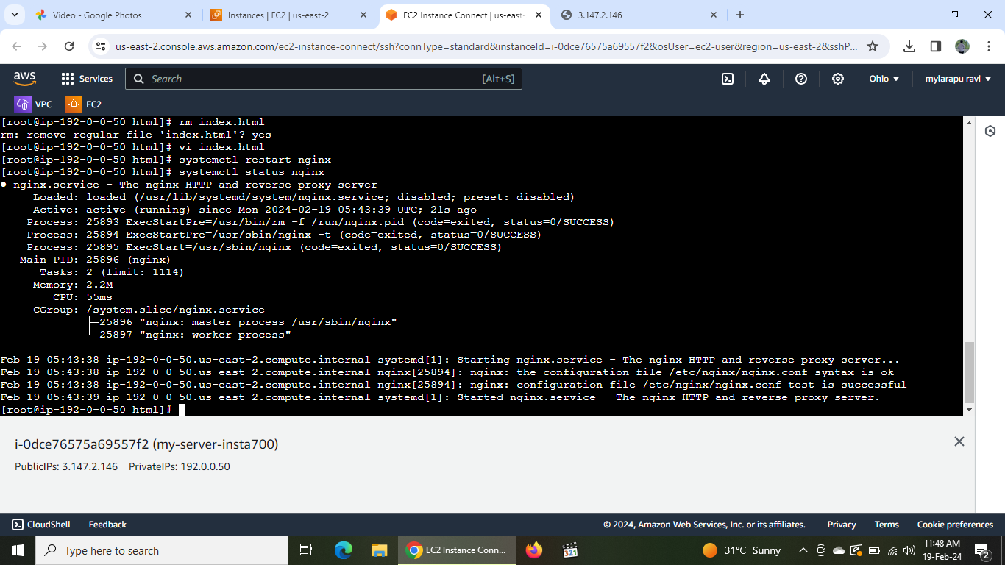

9.next copy the public ip address :80 see the inserting data

10.next create one more vpc in another region

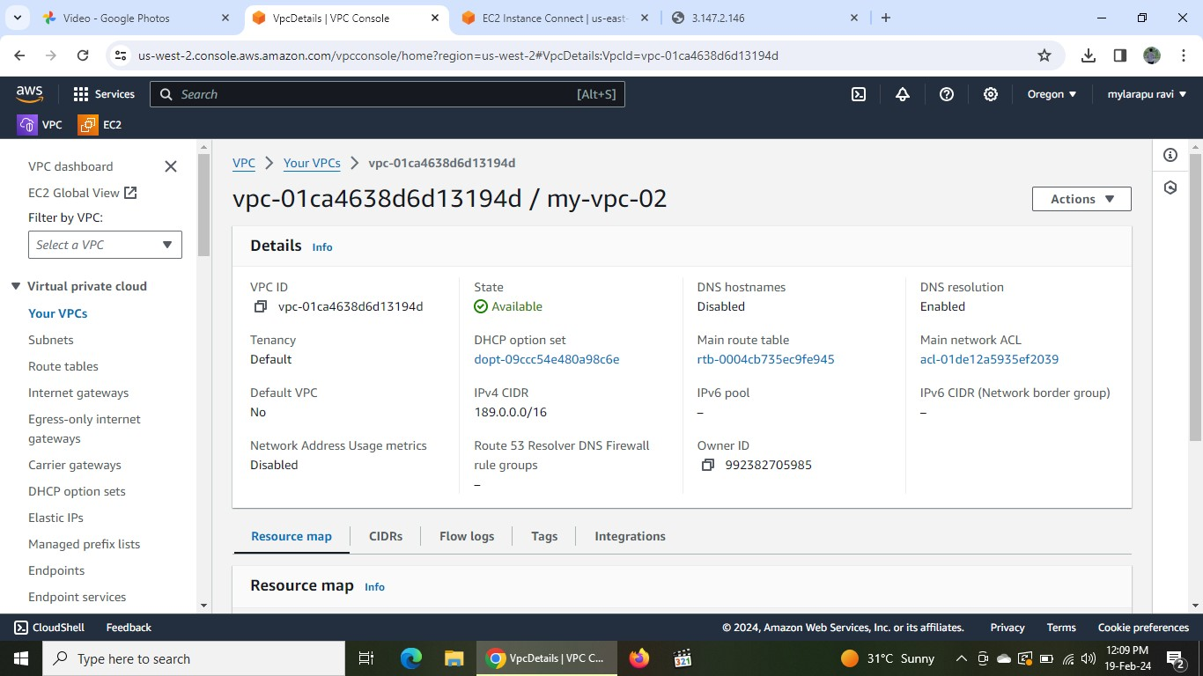

11.next create new instance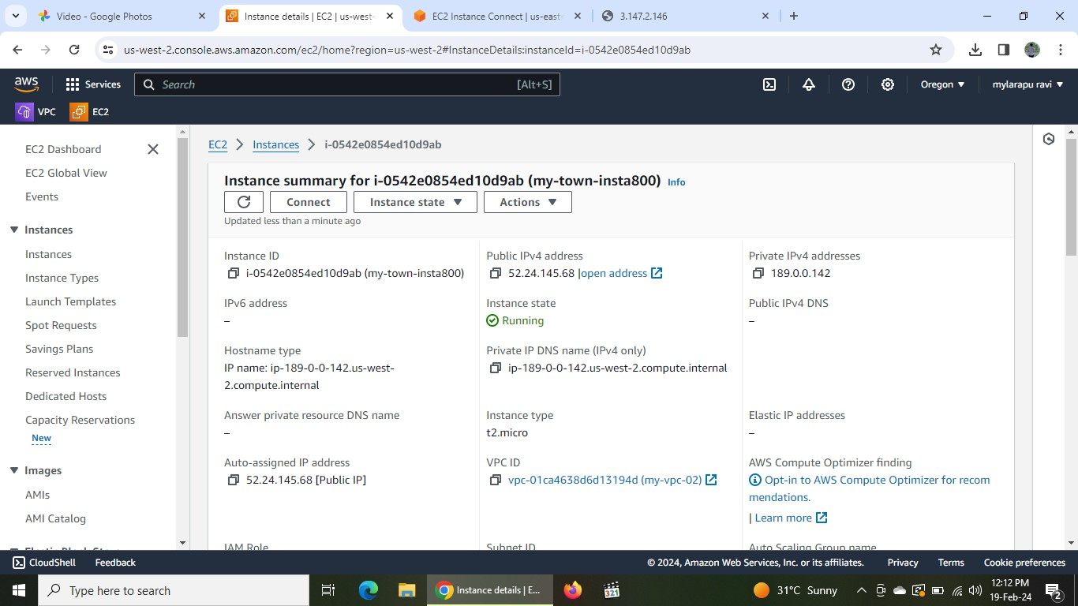

12.next create peering connection in vpc and add vpc id of the required region which is created on different region

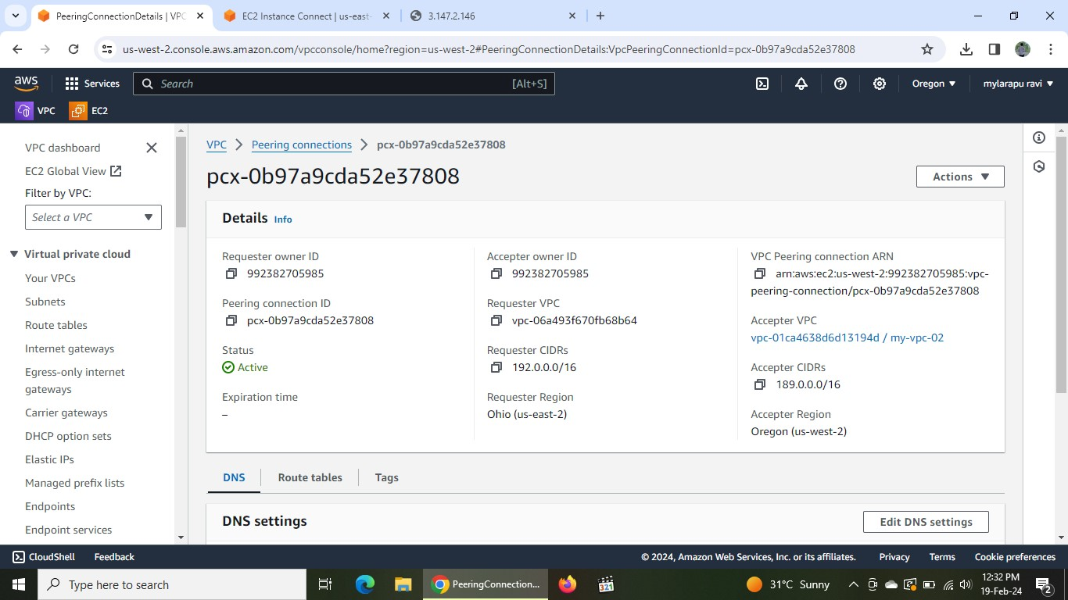

13.finally go the ec2 instance in the new region and connect to the root user and enter the command curl to check the peering connection with private ip different ec2 that has been created in other region 